Project Proposal

Digital Logic Design Lab


Project Title
2-Way Traffic Light Control System

Group Members
- 25P-0005 Waleeja Khan
- 25P-0011 Muhammad Awais

ABSTRACT:
This lab project involves designing and implementing a low-cost, automated Traffic Light Control System that displays a real-world, two-way road intersection using digital logic components. A 555 Timer IC is used to generate continuous clock pulses, which allows the CD4017-decade counter to work in a sequential manner for red, yellow and green light. The two roads are positioned to be in opposite states always, when one road's Red light is ON, the other's Green is ON, allowing a safe, alternating traffic flow using a single control circuit.
A 74LS192 counter and CD4511 decoder allows a 7-segment display to count for almost 3 seconds per light, completing one 9-second cycle before restarting, which gives a clear numeric hint of the time left before the signal changes. The project ensures a safe, coordinated two-way traffic flow and displays digital counting, decoding, and timing logic. The design has been verified on Multisim before implementation on hardware.
OBJECTIVE:
The Automated Two-Way Traffic Light Control System aims to design a hardware-based traffic control system, using integrated circuits, that:
- Cycles automatically through Red → Yellow → Green → Red using timer and counter ICs.
- Coordinates two roads in a way that only one has a green light at a time, allowing safe, alternating traffic flow.
- Shows a live countdown on a 7-segment display so drivers can see how much time is left in each signal phase.
METHODOLODY:
The project uses simple digital ICs instead of programmable logic. A 555 Timer generates continuous clock pulses, with resistors and capacitors setting the pulse rate. These pulses drive a CD4017 decade counter, which turns off its existing output and turns on the next one with each pulse.
Since Red and Green need to stay ON longer than Yellow, diodes (1BH62) group several CD4017 outputs per color, giving Red and Green a longer combined ON time than Yellow.
For 2-way operation, the CD4017 outputs are positioned so the two roads are always in opposite states, one road's Red light aligns with the other's Green, and both briefly shows Yellow during the switch, ensuring only one direction has traffic flow at a time, using a single counter and a set of diodes for both roads.
A 74LS192 decade counter and a CD4511 BCD-to-seven-segment decoder drive a 7-segment display, with each segment protected by a 220Ω resistor. The display counts down about 3 seconds per light, completing one full 9-second Red-Yellow-Green cycle before restarting.
Multisim Implementation:

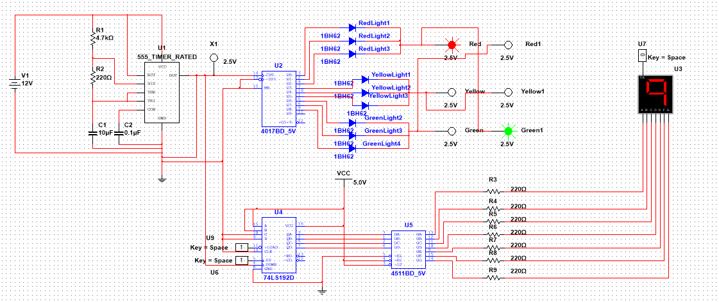

COMPONENTS:
- INTEGRATED CIRCUITS:
- NE555 Timer IC
- CD4017 Decade Counter
- 74LS192 Synchronous 4-bit Decade Counter
- CD4511 BCD-to-Seven-Segment Decoder
- DIODES:
- 1BH62 Signal Diode
- RESISTORS:
- 4.7k Ω
- 220 Ω
- CAPACITOR:
- 10μF
- 0.1μF
- INDICATORS (Probes)
- SWITCHES
- Push Button
- DISPLAY:
- Common-Cathode 7-Segment LED Display
- POWER & PROTOTYPING:
- Solderless Breadboard
- 12V DC Battery
- 5V Regulated Supply

